***Data Definition Language (DDL) and Data Manipulation Langauge (DML): -***

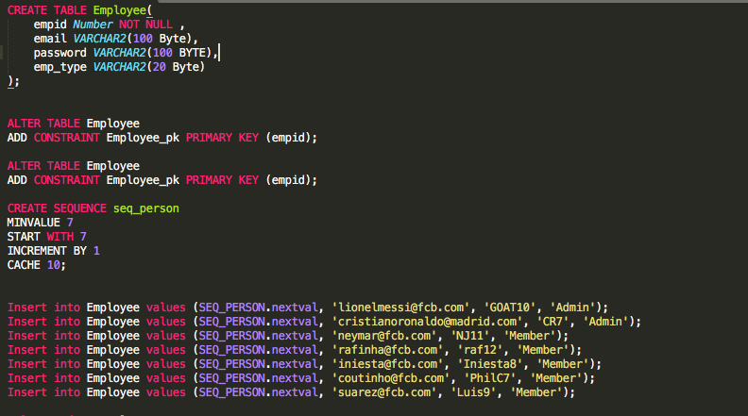

This is Employee table and created a sequence to generate next value which will act as primary key for this table. ( I started it from 10 with increment of 1 every time )

There are two Admin users and 5 normal users which I named as type Member.

Admin users as mentioned in requirements, they can see view multiple reports and manually can reset the monthly quota of credits for normal users to 1000.

While Normal users can assign or give away credits to other users and can also redeem credits that they have received as a gift from other members if the number of credits are greater than 10000.

Below is Employee details table in which user’s general information is stored like user’s first name, last name, address and contact information of user (Mobile phone).

Another table Credit which keeps a record of monthly credits a user has and gift credits and number of gifts redeemed.

Inserted some records to test the functionality like gift cards are increasing or not if a user redeem his gift credits.

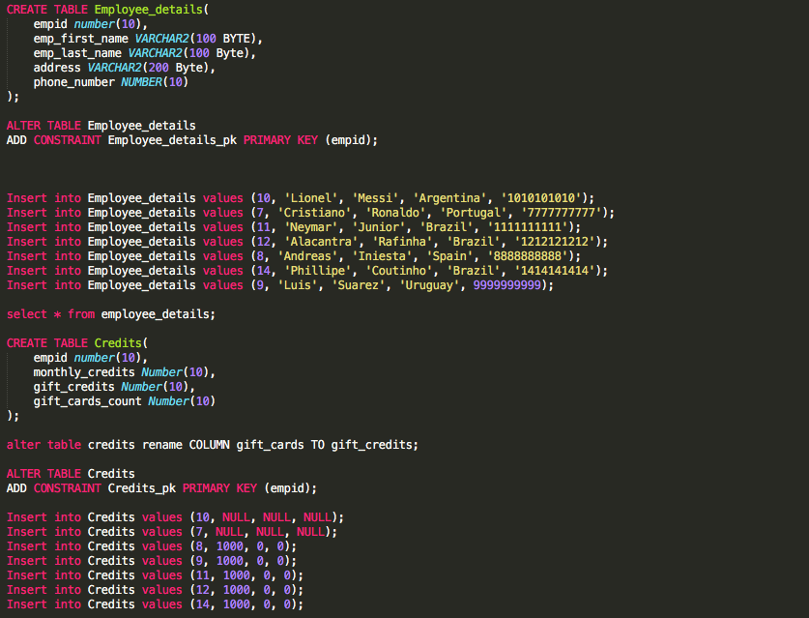

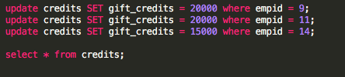

Created another table Transactions to keep track of all operations that are taking place like assignment of credits to other users and redeem of points and also store the date of operation.

Created a procedure to update the table when a user assigns the credits to other users. It will update the records in credit table and also insert the record in transactions table.

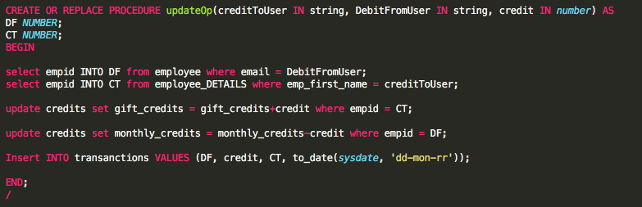

Created a procedure to redeem the gift credits. This will update the table credit by subtracting gift credits and updating gift cards count. It will also put a record in transactions table.

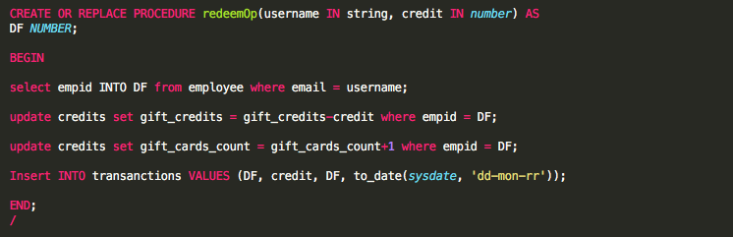

Admin user can see the reports of points given away and points received.

Created following views that will fetch the reports for points given away and points received and arrange them in descending order on month basis.

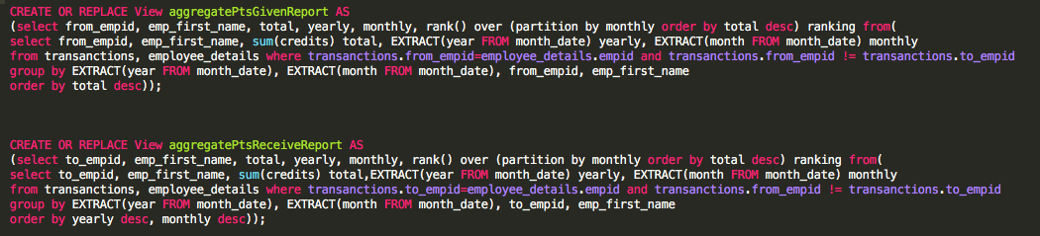

This below query will fetch the users who didn’t use all of their monthly credits or who didn’t use any of them. And create a report to show web.



Below query will return us the users who have redeemed their gift credits to buy gift cards and also display the number of gift crads.



This is more of a general report that shows users and their names and all type of credits (monthly credits, gift credits)

